Control of Infectious diseases: 1901 onwards
The decline in deaths from infectious diseases in Australia over the 20th century was substantial – and was reflected in the sharp drop in infant and child mortality and a more than twenty-year increase in life expectancy at birth.3,²5 Public health practices and policies did much to contribute to this achievement. In the early 1900s, infectious diseases were a major cause of death, with tuberculosis and sexually transmissible diseases being the commonest causes.26 One in ten children died from diarrhoeal disease, or enteritis, before they were five years old. However, from 1907 to 1980, the annual death rate for all ages from infectious diseases fell from about 250 per 100,000 population, to about 5 per 100,000 population. The rate then rose slightly, to around 9 per 100,000 in the year 2000, with increases in deaths from septicaemia, HIV/AIDS and hepatitis.²⁵ The fall in these death rates for males and females is shown below (Figure 1.1).
Figure 1.1: Dramatic decline in death rates for infectious diseases, 1907–2003
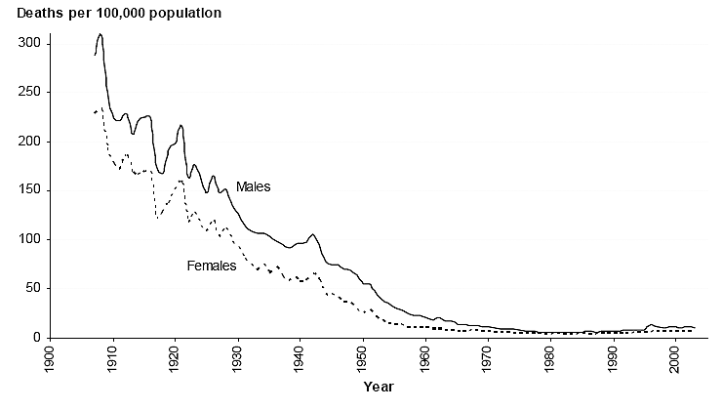
Source: AIHW, Mortality over the twentieth century in Australia, 2006, p. 36.
Influenza was also responsible for many deaths during the 20th century, with the greatest number occurring during the 1918-19 pandemic, when approximately 12,000 Australians died in less than a year, from a population of 4.9 million (Box 1.1).3
Box 1.1 Influenza, from 1918-19
The arrival of the great influenza pandemic in Australia was delayed until early 1919, because strict quarantine measures were adopted, despite some controversy over their appropriateness. A late epidemic occurred with a less virulent organism, but the pandemic still caused many deaths. Its impact is clearly evident in the ‘spike’ of deaths in Figure 1.1.
There were other significant influenza epidemics, such as the one that occurred in 1956-57.
Influenza pandemics and epidemics were controlled by a range of measures, including quarantine and population movement restrictions; public health campaigns against transmission by coughing and sneezing; and vaccination programs to curtail or constrain influenza in vulnerable populations (Sub-section 1.3.2).
During the 1970s and 1980s, new viral infections were described, including hepatitis B and C and the human papilloma viruses. HIV infection, first identified in 1981, caused a global pandemic, resulting in millions of deaths worldwide over the subsequent two decades.
In the early years of the 21st century, the appearance of ‘avian flu’ and SARS (Severe Acute Respiratory Syndrome) attracted worldwide attention, with the fear that some viruses might mutate to allow human-to-human transmission. These episodes illustrated the unpredictability of disease outbreaks and new infective agents. They also underscored the importance of disease prevention and ongoing monitoring of the factors that facilitated the emergence or re-emergence of infectious diseases.27
Public health practices
In the 20th century, public health actions to control ‘contagion’ were underpinned by the earlier discovery in the 19th century of micro-organisms as the cause of many infectious diseases (e.g., cholera and tuberculosis). Success in controlling infectious diseases resulted from improvements in:
- sanitation, hygiene and general living conditions (including less overcrowded housing and better nutrition) (Section 1.1);
- specific communicable disease control and surveillance measures (Section 1.2);
- the implementation of mass immunisation programs, starting with smallpox (Section 1.3); and
- improved clinical procedures (such as operative sterilisation techniques) which reduced the transmission between individuals, and antimicrobial drugs (Section 1.4).
Scientific and technologic advances played a major role in each of these areas and became the foundation for modern public health disease surveillance and control. Monitoring of notified infectious diseases allowed their spread to be tracked and responses initiated to contain them.
Successful public health measures to control infectious diseases used both universal approaches and the targeting of high-risk population sub-groups. Over the century, strategies became progressively more national in focus and in implementation, and were assisted by advocates and strong leadership, national policies and plans and enabling legislation (see below).
1908 Commonwealth Quarantine Act passed – the first federal public health legislation.
1930s-40s Marked declines in waterborne disease as a result of improvements in sanitation and drinking water treatment.
1932 Diphtheria vaccinations for children introduced as a national program.
1941 Penicillin developed by Australian researcher, Howard Florey and his team in the UK.
1942 Mass vaccination with pertussis vaccine commenced.
1947 Discovery of streptomycin as an effective treatment for tuberculosis.
1948- Tuberculosis Screening and Treatment Program initiated and conducted until 1975.
1951 Australian WHO Collaborating Centre for Reference and Research on Influenza established at the (then) Commonwealth Serum Laboratories.
1956 Mass vaccination with inactivated polio vaccine commenced.
1963 WHO guidelines on drinking water quality released.
1966 Oral poliomyelitis vaccine became freely available.
1970-71 Measles vaccine became freely available, and School-girl rubella vaccination program started.
1972 National Health and Medical Research Council (NHMRC) issued guidelines on drinking water quality in Australian capital cities, based on WHO guidelines.
1980 Global eradication of smallpox as a result of pioneering work by Australian microbiologist, Frank Fenner.
1982 First Australian case of HIV/AIDS diagnosed.
1983 Australia certified malaria-free by the WHO.
1987 ‘Grim Reaper’ HIV/AIDS media campaign launched.
1989 First National HIV/AIDS Strategy published. Communicable Diseases Control Network established (became the Communicable Diseases Network Australia [CDNA] in 2001). MMR (Measles-Mumps-Rubella) vaccine released for all infants at 12 months.
1992 National Water Quality Management Strategy launched.
1993 NHMRC recommended a National Immunisation Strategy. National Hib vaccination program initiated.
1995 Outbreak of E. coli associated with contaminated mettwurst consumption in SA – the national food authority asked to reform existing food hygiene standards. The Cooperative Research Centre for Water Quality and Treatment (CRCWQ&T) established.
1996 Australian Childhood Immunisation Register (ACIR) established.
1999 National Influenza Vaccine Program for Older Australians commenced (publicly-funded vaccine).
2000 Australia declared polio-free. Hepatitis B universal infant vaccine became available. National food safety standards developed. Establishment of OzFoodNet to ensure national collaboration with state and territory health authorities investigating foodborne disease.
2003 High-risk food industry sectors required to implement food safety programs based on Hazard Analysis and Critical Control Point methods.
2004 Further NHMRC Australian drinking water guidelines issued, incorporating a framework for the management of drinking water quality.
2005 National Pneumococcal Vaccination Program for Older Australians commenced. Varicella vaccine became available for children. NHMRC guidelines for managing recreational water released.
2006 National guidelines for water recycling (1st phase) issued - focus on treated sewage & greywater.
Table 1.1: Historic highlights of successful infectious disease control

Sanitation and hygiene
During the 19th century, the growth in population that followed industrialisation and immigration led to urban overcrowding, with poor quality housing serviced by inadequate water supplies and waste-disposal systems. This resulted in repeated outbreaks of cholera, dysentery, tuberculosis, typhoid fever, influenza, plague and smallpox in many of Australia’s capital cities.³
However, the incidence of these diseases began to decline with the introduction of public health measures, such as publicly-financed water and sewerage schemes, improved sanitation and better housing; and these improvements continued well into the 20th century.^{3,}28 Local, state, and federal government efforts reinforced the concept of collective ‘public health’ action. Control of animals and other pests also contributed to reductions in infectious diseases.
Survey respondent: ‘Safe drinking water and improved sanitation in the early decades of the 20th century [were public health successes], especially for their impact on infant mortality… the evidence shows that infant mortality fell drastically during the early decades of the century and that this was substantially due to the more sanitary living conditions that mothers and babies experienced. This impact on infant health and infectious disease was greater than any subsequent public health measures including various medical interventions (vaccination, antibiotics) available later in the century. This also related to urban planning which in the early decades of the century placed importance on good ventilation, space, reducing overcrowding etc. and more orderly growth of towns, planning which also had implications for better sanitation and water supply infrastructure.’
Quarantine played an early role in preventing the arrival and transmission of human infectious diseases. In 1900, an outbreak of bubonic plague in Sydney was the trigger for the first federal quarantine activity. An Australian medical researcher, Ashburton Thompson, was in charge of the measures taken to combat it, and became the first person to establish the connection between rats, fleas and the spread of plague to humans.29
By the end of the century, quarantine remained important in preventing the transmission of diseases, which might have had detrimental effects on the Australian economy. Control through quarantine at the point of entry to Australia was effected under the Commonwealth Quarantine Act 1908 and covered animals, plants and humans. It was administered by the Australian Quarantine and Inspection Service, which had the emergency power to override any state-specific quarantine controls.30
From the 1930s to the 1950s, state and local health departments made substantial progress in disease prevention activities, including sewage disposal, water treatment, food safety (Sub-section 1.1.2), and public education about hygienic practices (e.g., food handling and hand washing).

Clean water
1901 onwards
‘The treatment and disinfection of drinking water has dramatically lowered the incidence of waterborne disease outbreaks since the early part of this century.’ —Productivity Commission, Arrangements for setting drinking water standards: international benchmarking, 2000, p. 21.
The provision of safe drinking and recreational water was a significant public health achievement in the 20th century. As improvements in drinking water treatment and sanitation were implemented, major reductions in waterborne diseases occurred, and deaths from diarrhoeal diseases declined rapidly over the first half of the century, especially in children aged 0-4 years (Figure 1.2).
Figure 1.2: Decline in death rates from diarrhoea, males and females, 0–4 years, 1907–2003
SHAPE \* MERGEFORMAT 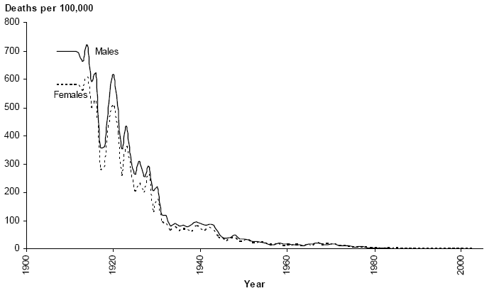
Source: AIHW, Mortality over the twentieth century in Australia, 2006, p. 48.
In 1907, diarrhoeal disease was the third leading cause of death for both males and females, and was responsible for more than seven per cent of all deaths.13 The impact on young children was particularly severe, with diarrhoea the cause of around one quarter of all deaths of infants aged under 12 months.25 By the year 2000, diarrhoeal deaths were less than one per 100,000 children, a very substantial fall from a rate of more than 600 deaths per 100,000 children in 1907 (Figure 1.2).13
The first colonial Act in Australia was passed in 1850 in Sydney, with the aim of ‘sewerage, cleansing, and draining… to promote the health of the inhabitants’.5 In 1875, the Sydney Sewerage Board reported that 4,700 of the city’s 5,400 ‘water closets’ (toilets) were polluting the drinking water mains with sewage. Protection of water supplies from sewage pollution was one of Australia’s earliest public health measures, and an underground sewerage system for Sydney was completed in 1889. Similar construction in other Australian cities followed.
‘By the early twentieth century, better protection of water supplies from sewage pollution and simple but effective methods of water treatment (chlorination, sand filtration) had greatly reduced rates of waterborne disease... Since then, scientists and engineers have been developing ways of processing water more quickly, more effectively, in a more controlled way and at lower cost.’ - Cooperative Research Centre for Water Quality and Treatment, 2003.31
Chlorination was introduced in the 1930s and 1940s throughout the developed world, when it became evident that filtration and disinfection with chlorine were key factors in preventing outbreaks of cholera and typhoid fever.31 From then on, a range of water treatment methods was developed and implemented. Coagulation, flocculation, sedimentation and filtration together or in combination, were the most widely used technologies from early in the 20th century.31 Coagulants (such as alum) helped particles separate out as sediment, effectively removing almost all the bacteria and viruses from water supplies. Filtration removed smaller particles, using sand, gravel or charcoal filters or newer synthetic materials, and later, microfiltration using membranes was used.31
By the end of the century, the public health system that provided clean, safe drinking water to the population comprised many different elements. The delivery of safe drinking water was the responsibility of state and territory governments. Government health and water resource departments were authorised to regulate and monitor standards for drinking water quality, although responsibility for other components of the system rested with water corporations, storage facilities, water catchment and environmental protection agencies, and others. While national guidelines for water quality standards had been developed, differences in standard setting, regulation and quality of water delivered were still apparent across the country in 2000.32
The first World Health Organization (WHO) Guidelines on drinking water quality were released in 1963. In 1972, a set of guidelines for drinking water quality in Australian capital cities was issued in line with the WHO Guidelines.32 Quality standards for drinking water were then regularly updated. The 1980 revision of the guidelines (published jointly by the NHMRC and the Australian Water Resources Council) was considered a landmark in water quality management, as it was the first time that the various water supply and health authorities had worked together to produce a single guideline document for Australia.33 There were subsequent revisions of the national Australian drinking water guidelines (in 1987, 1996 and 2004) for water supply ‘from catchment to tap’.34
‘A major contributing factor to the high standard of living across most of urban Australia [was] the quality of town water supplies.’
—W Maher, I Lawrence & A Wade, Drinking water quality, DEST, Canberra, 1997, p. 5.
A National Water Quality Management Strategy (NWQMS) was launched in 1992 to coordinate the management of water resources as part of sustainable development,35 and was included in the Council of Australian Governments (COAG) Water Reform Framework from 1994.36 The Cooperative Research Centre for Water Quality and Treatment (CRCWQ&T) was established in 1995 as the principal research and development agency for drinking water quality in Australia.
In 1998, there were a number of Cryptosporidium water contamination incidents in Sydney, although people did not fall ill as a result (Box 1.2). While the contamination was at levels below the standard for drinking water, these incidents nevertheless raised public concern.37 A water sector study by the Productivity Commission in 2000 compared regulatory processes for the development and enforcement of drinking water quality standards against accepted best practice, and found a ‘diversity of approaches to developing, promulgating and enforcing standards’ with considerable scope for improvement.32
Box 1.2 Water quality and Cryptosporidium
In July 1998, routine water testing identified Cryptosporidium oocysts and Giardia cysts at high levels in treated Sydney drinking water. In the absence of evidence-based guidelines for public health action, and in light of overseas reports of major outbreaks of disease linked with contaminated municipal water systems, NSW Health responded by issuing a series of ‘boil-water’ alerts. These lasted intermittently until mid-September of that year.
Sydney residents had opportunities for exposure to Cryptosporidium and Giardia in drinking water before the boil-water alerts were issued, and compliance with the alerts was far from complete. However, enhanced surveillance through laboratories, general practitioners, emergency departments, pharmacies and nursing homes, as well as the usual notification system, did not reveal any increases in diarrhoeal illness in the Sydney area.
Laboratory reports of giardiasis increased slightly, as did isolation of other gastrointestinal pathogens that were unrelated to drinking water. This suggested that the results were probably due to increased testing, and identification of background cases unrelated to Sydney water. Positive outcomes of the crisis included the development of protocols for the issuing of future boil-water alerts and information to consumers, health care facilities, manufacturers and others on reducing the risk of cryptosporidiosis.
However, many questions remained unanswered about factors affecting the viability, infectivity and pathogenicity of Cryptosporidium and Giardia in water, and additional research was needed.
Source: Public Health Division, The health of the people of New South Wales - Report of the Chief Health Officer, NSW Department of Health, Sydney, 2002 [adapted].

For example, cost-benefit analysis was rarely used in the development of standards, and there was an ‘absence of rigorous regulatory assessment’ and a lack of information on drinking water quality and accompanying risk levels across Australia.32 There were also divided responsibilities for water regulation, and limited transparency and accountability. The review was timely, as many urban water sectors in Australia were facing potentially large investments in treatment technologies in order to meet increasingly stringent water quality standards.
By 2000, an estimated $400 million a year was being spent on water treatment and it was acknowledged that higher standards of water safety would increase treatment costs.32 Comparison with other countries suggested that insufficient resources were being dedicated to drinking water standards activity in Australia, and changes to institutional structures and regulatory processes were necessary.32
Public health regulators then worked with industry to develop a risk management framework for managing safe drinking water supplies. This was the principal focus of the Australian Drinking Water Guidelines released in 2004.33 That year, as part of the National Water Initiative, a process for public consultation to finalise the draft NWQMS guidelines on water recycling was also agreed. Two draft documents were available for comment in 2006, and the Phase One guidelines were endorsed by the Environment Protection and Heritage Council, the Natural Resource Management Ministerial Council and the Australian Health Ministers’ Conference.38 The guidelines provided a national reference for the supply, use and regulation of recycled water schemes with a focus on treated sewage effluent and greywater.39 Phase Two of the guideline development focused on stormwater reuse, managed aquifer recharge and recycled water for drinking.
The quality of recreational water was regulated by state, territory and local governments, safeguarding water for activities such as swimming, surfing and boating. This was to prevent gastroenteritis, respiratory illness, and eye, ear-nose-throat and skin infections, which were associated with recreational exposure to contaminated beach water.40 In 2005, the NHMRC issued Guidelines for managing risks in recreational water, which revised existing guidelines to aid the development of standards and legislation to manage safe, recreational water environments.41
Public health practices
The major reductions in waterborne diseases, which occurred from the early 1900s as improvements in drinking water treatment and sanitation were implemented, illustrated the potential for universal public health measures to make a major contribution to the population’s health. By the end of the century, the public health standard was for safe drinking water to be delivered into the home for most people in the majority of communities in Australia.
A preventive approach was essential to assure the quality of drinking water. Drinking water had to meet appropriate standards for microbiological, chemical and radiological contaminants, and for physical characteristics (e.g., odour, taste and clarity) as determined by the NMHRC guidelines. These incorporated world standards set by the WHO. Water quality was monitored and tested to ensure compliance and that measures were in place to contain any breakdown in quality that might emerge.
In Australia, as in other developed countries, the scope and precision of drinking water guidelines and standards became more comprehensive as public health knowledge, community awareness and the demand for high quality water increased.32 Standards for recreational water were also developed. The public health principle of prevention was systematised through the incorporation of a risk management approach, a useful preliminary for cost-benefit analyses of further public health investments in water treatment.
Factors critical to success
Successful public health measures to control infectious waterborne diseases were based on universal approaches, such as separating all sewage from drinking water and sewering all urban developments. Public health analyses of risk and of the level of precautions that should be communicated to the population after events when the risk of infection had been increased temporarily, were tailored to address those groups most-at-risk.42 Over the century, the public health strategies and guidelines that were developed became progressively more national in focus, while their implementation remained at the level of government closest to the local population. State, territory and local government legislation and regulation also contributed to the success of clean water initiatives.
Safe drinking water strategies successfully established standards, guidelines and model provisions for the diverse agencies that were responsible for providing drinking water to the population. Their contribution to public health should not be under-estimated. Goslin, for instance, noted the ‘invisibility of public health’ when it was working well - in relation to safe water, food and products - as one explanation for why public health interventions were ’politically and publicly under-appreciated’.43
The provision of safe drinking water and of methods to ensure safe recreational water, made a measurable improvement in the health of the population. Water is essential for life and ensuring its safety for drinking and recreation remained a significant focus for public health activity.
Future challenges
By the end of the 20th century, the delivery of quality-assured, safe drinking water to all Australian communities was still to be achieved. For communities not connected to mains water supply, some provision for the supply of safe drinking water was essential. This could be groundwater, stored rainwater or a combination of both. For many small communities in remote parts of Australia, however, the provision of an adequate supply of water was an ongoing challenge. Many of these were Indigenous communities. Information from the 2001 Community Housing and Infrastructure Needs Survey (CHINS) revealed that nearly half (98 of the 213 Indigenous communities with a population of 50 or more) were not connected to a town water supply, and water quality had failed testing or was not tested in the year previous to the survey.44
Future strategies generally included the delivery of recycled water that was safe for drinking. Growing populations and greater urban density were also increasing the risk of exposure to pharmaceuticals in drinking water. Both surface and ground waters can be contaminated by effluent discharge; and stable compounds are not affected by advanced filtration technologies and can re-appear in drinking water. Environmental monitoring and toxicological testing for the commoner pharmaceuticals were suggested as priorities.45 Other chemicals remained a problem, including pesticides, but there were methods to remove these. Evaluating the likely public health benefits and capital costs of investments to upgrade water protection and treatment systems to meet the requirements of more stringent drinking water guidelines and standards remained an issue.32
Survey respondent: ‘The majority of Australians have access to drinkable water however some of the highest risk groups (e.g., remote Indigenous groups) still don’t have this.’
As well as the priority of delivering safe, clean drinking water to all Australian communities, other challenges included:
- establishing standards for water recycling - becoming increasingly important as a result of population growth and long-term changes in climate;
- maintaining the protection of existing water supplies and catchment areas to human and environmental health; and
- introducing water fluoridation in Queensland and to additional, mostly larger regional communities (Box 3.1).46

Food safety
1901 onwards
At the beginning of the 20th century, food was a common route for the transmission of infectious diseases. Foodborne diseases occurred as a result of bacteria (e.g., Salmonella, Campylobacter), parasites (e.g., Cryptosporidium), toxins (e.g., from Staphylococcus aureus), and viruses (e.g., noroviruses, hepatitis A), with bacterial causes being the commonest.47, 48 Foodborne disease outbreaks were more likely to originate in the home and to be limited in scope. Typical sources included family meals and home-preserved goods. Towards the end of the century, foodborne diseases were more likely to be contracted outside the home (as more people bought pre-prepared food and ate out more often), or as a result of travelling to another country. By then, most foodborne infections were of relatively short duration, although some occasionally led to more serious, even chronic consequences, as well as death.
Much foodborne disease was avoidable. Early public health legislation, such as the Victorian Public Health Act 1854, provided for Local Boards of Health to inspect places used for the ‘sale of butchers’ meat, poultry or fish, or as a slaughter house’, and to seize and destroy any food that was unfit for human consumption.⁵ Initially, control of food under Health Acts focused on issues of cleanliness (e.g., in slaughterhouses and the disposal of putrefying food) and adulteration (e.g., the watering down of milk), with a later emphasis on the purity of food, to ensure that consumers received full value for their money.
By the 1950s, state and local health departments had made substantial progress in foodborne disease prevention, including food safety inspection and public education about hygienic food storage and handling practices. The advent of refrigeration and its gradual spread throughout the food industry and the community, improved food safety and the ability to store nutritious foods, such as milk and meat for longer periods (see Sub-section 4.1 and Box 4). Pasteurisation of milk successfully prevented the spread of bovine tuberculosis (TB).
A major reform of food safety in Australia followed a high-profile outbreak of foodborne illness in South Australia in 1995, caused by the contamination of mettwurst with Escherichia coli (E. coli O111). One child died, 23 children were hospitalised with Haemolytic Uraemic Syndrome (HUS) (five suffered ongoing illness), and a further 150 people developed other health-related conditions.49 The outbreak highlighted a number of risks in the manufacture and regulation of certain meat products.
In July 1995, Health Ministers asked the (then) Australia New Zealand Food Authority (ANZFA) to reform existing State and Territory food hygiene standards which had become outdated and inconsistent.50 As a result, Australia had uniform national food safety standards from 2000. Further reform occurred in 2003, when the Australia and New Zealand Food Standards’ Council agreed that four high-risk food industry sectors should be required to implement Food Safety Programs based on the principles of HACCP (Hazard Analysis and Critical Control Points).51 This was a systematic preventive approach to food safety, to identify potential food safety hazards so that key actions (known as Critical Control Points) could be taken to reduce or eliminate them.
Both food codes and standards changed as a direct result of the contaminated mettwurst outbreak in SA. Scientific testing methods and food safety monitoring systems also improved. The meat industry invested significantly in quality assurance and HACCP programs to ensure the safety of their food products and regain customer confidence after a number of food contamination incidents.49
Surveillance at selected monitoring sites, established in 2000 by the Australian Government, identified 624 outbreaks of gastrointestinal illness affecting 10,865 persons during 2005 (Figure 1.3).52, 53 Consumption of contaminated food and/or water was the suspected cause of 102 of these outbreaks (giving an overall rate of 5.0 foodborne outbreaks per 1,000,000 population). The 102 outbreaks affected 1,975 people. Four of these people died and 166 were hospitalised. Restaurants, domestic kitchens, professionally catered events, and aged care homes were the usual settings involved in outbreaks, with Salmonella the most common agent of foodborne infection.54
Much illness caused by foodborne disease went unreported, and the total health impact was therefore difficult to calculate. Data from the National Gastroenteritis Survey 2001-02 were used to estimate that at least 5.4 million cases of gastroenteritis in Australia each year originated from contaminated food (32% of the estimated total of 17.2 million gastroenteritis cases in Australia annually; an incidence of 0.29 cases per person per year, or one episode per person every three to four years).55
Foodborne gastroenteritis was estimated to result annually in approximately:
- 1.2 million doctor visits;
- 300,000 antibiotic prescriptions;
- 15,000 hospitalisations; and
- 2.1 million lost work-days.
Figure 1.3: Suspected mode of transmission of gastroenteritis outbreaks, 2005 (624 outbreaks)
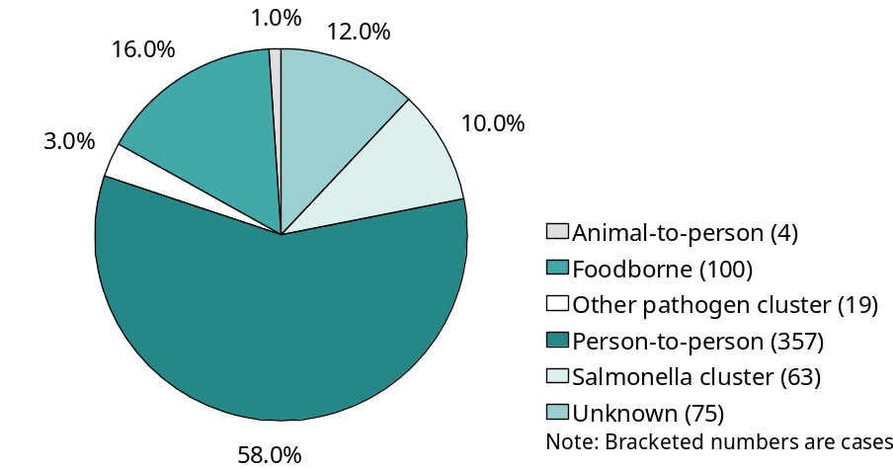
Source: OzFoodNet Working Group, Communicable Diseases Intelligence, vol. 30, 2006, p. 287.
Furthermore, there were an estimated 42,000 subsequent episodes of conditions resulting from acute gastroenteritis (including 21,000 episodes of reactive arthritis, and 20,200 episodes of irritable bowel syndrome). Containing foodborne diseases and ensuring food safety remained important public health activities.
Public health practices
National, state, territory and local governments, and the food industry, all had responsibilities for maintaining and improving the safety of food in Australia, and for ensuring the effectiveness of food regulation. With the focus on prevention, public health professionals played important roles in preventing foodborne disease (e.g., through local government public health inspection of restaurants and other places where food was prepared and sold) and in investigating and responding to foodborne disease outbreaks when they occurred (Box 1.3).56
Diseases that were potentially foodborne (such as campylobacteriosis, HUS, cryptosporidiosis, hepatitis A, listeriosis, salmonellosis, shigellosis, and typhoid) were required by law to be notified by doctors and pathology laboratories to state and territory health authorities, which reported them to the National Notifiable Diseases Surveillance System. Government public health units initiated investigations in order to contain outbreaks quickly, prevent further spread, and monitor interventions.
The OzFoodNet network was established in 2000 by the Australian government to ensure national collaboration and coordination with state and territory health authorities in the investigation of foodborne disease, and to improve the understanding and evidence base of causes in the community in order to reduce food poisoning.⁵² OzFoodNet monitoring sites reported regularly on outbreaks of gastrointestinal and other foodborne illness, people affected (including deaths and hospitalisations), suspected modes of transmission, common settings and infectious agents (e.g., Salmonella).⁵³
Box 1.3 Outbreak response case study: an outbreak of Hepatitis A
By June 30 [1997], 23 cases of hepatitis A linked to attendance at a popular restaurant (Restaurant A) had been notified to [a regional] Public Health Unit [PHU]. Of the cases, 11 (48%) were females with ages ranging from seven to 48 years. All cases reported the onset of jaundice from June 2. Nineteen cases reported eating at the restaurant on Mother’s Day (May 11), and four reported eating there on the following Sunday. PHU staff inspected restaurant A on June 12. Blood was taken from all 20 food handler employees identified by the proprietor as working on Mother’s Day, and all tested negative for recent hepatitis A infection.
On June 18, the Health Department issued a warning through the media advising that patrons who had attended the restaurant since May 1 may be at risk of hepatitis A, and those patrons who developed any symptoms of illness should contact their medical practitioner. The restaurant voluntarily closed until the source of infection was identified.
A case-control study was conducted [on] 22 cases and 72 diners who had eaten at the restaurant on Mother’s Day identified from Restaurant A’s reservation list. Preliminary analysis showed that all cases, but only 53 (74%) controls, reported eating prawns at the restaurant. Cases reported consumption of no other common food items.
The prawns served at Restaurant A in June were traced to a batch of imported frozen fresh-water prawns. In response to the epidemiological and food inspection findings, the importer voluntarily recalled the remaining prawns from the distributors and Restaurant A was allowed to reopen for business.
Source: ‘Hepatitis A outbreak linked to a Sydney restaurant’, NSW Public Health Bulletin, vol. 8, no. 6-7, 1997, p. 51 [adapted].
A review of foodborne disease outbreaks from 1995 to 2000 supported the direction of public health activities in moving to risk-based food safety interventions, focusing on mass catering, hospitals, and aged-care facilities.57 It found that outbreaks in aged-care and hospital facilities were associated with 35% of the 20 deaths attributed to foodborne illness during the period. These data showed the importance of continuing to improve public health measures to ensure food safety and contain foodborne disease especially among vulnerable population groups, such as the elderly and the chronically ill.
Factors critical to success
Successful public health measures to control foodborne diseases and improve food safety used universal preventive approaches across the population. Early in the century, critical action was taken in regard to issues of cleanliness and hygiene, eliminating, where possible, the disease pathways as they were identified (e.g., pasteurising milk to prevent the spread of TB). Public education, from early hygiene classes taught at schools to health promotion activities such as pre-Christmas radio warnings about how to cook turkeys safely, also played a part. The Australian community as a whole became better informed about safe food preparation and handling practices by the end of the 20th century, although there was room for further improvement.
Over the century, strategies were progressively more national in focus and in implementation, assisted by national legislation and regulation systems, in combination with surveillance and monitoring. The development of local public health units into a sophisticated rapid response system that reported, shared and responded to critical information to contain outbreaks when they occurred, also contributed to success in this area.
After the contaminated mettwurst outbreak in SA in 1995, food codes, standards, scientific testing methods and food safety monitoring systems were improved and became more effective.58 Development of robust monitoring and reporting mechanisms was increasingly applied nationally (e.g., OzFoodNet) as well as the requirement to notify cases of foodborne diseases. There was ongoing work on information systems to: support the practical application of HACCP; improve rapid dissemination of information on foodborne disease outbreaks using websites and commentary from multiple sources; build active surveillance networks that could share, for instance, molecular information between public health agencies; and provide online educational packages to food industry personnel.59,60
The food safety system that developed was national in scope, with participation from all states and territories, as well as from stakeholders from government (e.g., public health units, pathology reference laboratories, and local government inspectorates), private industry (e.g., food manufacturers, restaurants) and the agricultural sector. Developments in food science, microbiology and epidemiology also contributed to improvements in food safety, as well as guidelines to assist high risk businesses implement comprehensive food safety programs. There was success in eliminating a number of avenues of infection, although food safety remained a matter for public health vigilance and action.
Cost-effectiveness
Although much foodborne disease went unreported, foodborne disease was reported to cost as much as $1.25 billion annually in Australia.61 Productivity and lifestyle costs were estimated at $772 million (62% of the total), followed by the cost of premature mortality ($232 million).61 Health care service costs were quantified at $222 million, with the majority being attributed to emergency care, general practitioner and specialist services. Gastroenteritis accounted for an estimated $811 million annually (81% of the productivity, lifestyle and premature mortality costs) while another seven foodborne illnesses were prominent cost contributors, including listeriosis and reactive arthritis.
There was evidence that the benefit to the community of the food safety system that was in place outweighed the cost of foodborne disease prevention, surveillance, and outbreak responses. Large, uncontained outbreaks had the potential to be expensive to control and to lead to significant business losses through reduced consumer confidence (e.g., compared to the economic costs to the beef industries in various overseas countries arising from ‘Mad Cow Disease’62). In Australia, the actual direct cost (to health authorities and industry) of the contaminated mettwurst outbreak in SA in 1995 was estimated at $20 million (in 2000) and continuing to rise. ANZFA calculated a $400 million cost to Australian industry from the decline in trade attributable to the 1995 mettwurst outbreak, together with a subsequent Salmonella outbreak in 1997.50
The National Risk Validation Project identified high-risk food businesses that were consistently associated with foodborne disease outbreaks, and analysed the benefits and costs of implementing HACCP food safety programs in these sectors. Food businesses or sectors ranked as high-risk are shown in Table 1.2, together with the per meal costs of illnesses caused by foodborne diseases, and the benefits from implementing food safety programs, thereby preventing food-related disease.49
The Project found that the aggregated costs associated with foodborne illness in Australia were in excess of $1.67 billion a year. Costs per industry ranged from $75 million to $540 million per year, but it was the cost of foodborne illness per meal consumed that highlighted the very high costs associated with raw, ready-to-eat seafood (at $4.87 per meal compared to $0.49 for general catering). The most conservative benefit to cost ratios were assessed as ranging from 6.5 to 115.9 for the four highest risk sectors: seafood, catering, processed meat, and food service to vulnerable populations such as those in hospitals and aged-care facilities. The findings demonstrated that the benefits of implementing and operating food safety programs far outweighed the costs of doing so for most high-risk food industries, and reinforced the conclusion that ‘the community would be better off as a result of mandatory food safety programs’.63
Table 1.2: Costs of foodborne illness and benefit-cost ratios for high-risk food industries
High-risk food industries | Cost of foodborne illness per meal ($) | Benefit-cost ratios
High-risk food industries | Cost of foodborne illness per meal ($) | Class 1  outbreaks | Class 1 & 2 outbreaks
1. Food service for sensitive populations | 0.21 | 6.5 | 6.8
2. Producers, harvesters, processors and vendors of raw ready-to-eat seafood | 4.87 | 25.8 | 25.8
3. Catering operations serving food to the general population | 0.49 | 9.9 | 10.4
4. Eating establishments | 0.06 | 0.8 | 0.9
5. Producers of manufactured and fermented meats | 0.39 | 115.9 | 165.6
Note: Class 1 outbreaks assume that the cause of illness would have been detected and remedied by measures put in place under a food safety program; Class 2 outbreaks assume there is insufficient information to estimate likely effectiveness.
Source: Food Science Australia & Minter Ellison Consulting, The National Risk Validation Project, 2002, p. 8.
Future challenges
By the end of the century, three areas of food safety that required further attention were:
- the impact of global climate change;
- improving food safety and quality in remote Indigenous communities and for other vulnerable populations; and
- the impact of population ageing.
As the incidence of bacterial foodborne diseases increased during summer months, and was greater in the warmer northern regions of Australia, the expectation that average temperatures would continue to rise as a consequence of global warming meant that it was likely that rates of foodborne diseases would also rise.^{55,}64^{,65,66} In addition, infectious diseases (e.g., salmonellosis, cholera, and giardiasis) were known to thrive in the after-effects of environmental disasters. As extreme weather events (e.g., floods, storms, cyclones) were expected to become more frequent as a result of climate change, an increase in waterborne diseases was also identified as a potential threat, ‘especially in impoverished areas’.67
A lack of infrastructure such as all-weather roads and reliable electricity supply in many remote communities meant that the transport, storage, refrigeration, and preparation of the fresh foods that were essential for good health could be compromised. These factors directly affected the health and wellbeing of those who lived in these areas of Australia, most of whom were Aboriginal and Torres Strait Islander peoples; and were reflected in the very high rates of severe gastroenteritis and malnourishment seen in children from these communities.⁶8,69 The challenge was to provide all Australian communities with the infrastructure to support the provision of safe, nutritious food.
Australia’s population was ageing and foodborne disease was known to affect vulnerable populations, including the elderly, more severely than others. Thus, the effects of foodborne illness were likely to be more widely distributed in the future.

Screening and infectious disease surveillance
1901 onwards
The 20th century saw the development of a wide range of technological advances in detecting and monitoring infectious diseases, which contributed to the achievements of public health in controlling them. Towards the middle of the century, the incidence of tuberculosis (TB) declined as improvements in housing continued to reduce crowding, and the national tuberculosis control program of free chest x-ray screening was initiated in 1948 in an effort to find cases early and treat them (Sub-section 1.2.1). Public health strategies to detect and manage sexually transmissible infections included confidential clinics, notifiability and contact tracing, and were extended to education campaigns in schools and social marketing about safe sexual practices. As a result, there were reductions in syphilis and other sexually transmissible infections (e.g., gonococcal infections). Congenital syphilis was almost eradicated.
There were major improvements in both state-based and national surveillance of infectious diseases through mandatory notification and other alert and control systems, and advance planning for epidemics, such as avian (bird) flu. The control of epidemics was the role of state and territory communicable disease control units, which undertook contract tracing and outbreak investigation. Control of animal sources of infection (e.g., bovine tuberculosis, brucellosis in domestic animals) was also an important preventive activity. Screening of blood donations removed a potential cause of inadvertent human-to-human transmission of many infectious bloodborne agents.
Some diseases, such as leprosy, malaria and dengue, were far more prevalent in northern parts of Australia, and their control and treatment remained a challenge. Sanatorium treatment, essentially isolation of infectious cases, remained a possible public health intervention for the treatment and containment of drug-resistant strains of diseases (e.g., multi-drug-resistant tuberculosis). Diseases that arose over the 20th century, such as HIV/AIDS, presented new challenges in their prevention, treatment and control (Sub-section 1.2.2). Screening and treatment for Chlamydia infection in young women gained in significance, and it was the most frequently notified infectious disease in 2004 (there were 41,311 diagnoses in 2005, a four-fold increase over the previous ten years), with untreated Chlamydia becoming a significant cause of infertility.70 Chlamydia, gonorrhoea, syphilis and hepatitis C were all commoner in Aboriginal and Torres Strait Islander peoples, and the incidence rates of Chlamydia and gonorrhoea increased considerably between 1994 and 2004 in these groups.
The following sub-sections focus on two successful public health activities, Tuberculosis control (Sub-section 1.2.1) and the HIV/AIDS Strategy (Sub-section 1.2.2).

Tuberculosis control
1948 onwards
At the beginning of the 20th century, tuberculosis was the leading cause of death among females, and the second largest cause of death among males. In 1907, death rates were 121 per 100,000 population for males (Figure 1.4), and 93 per 100,000 population for females (Figure 1.5).
Figure 1.4: Age-specific and age-standardised death rates for TB, males, 1907-2003
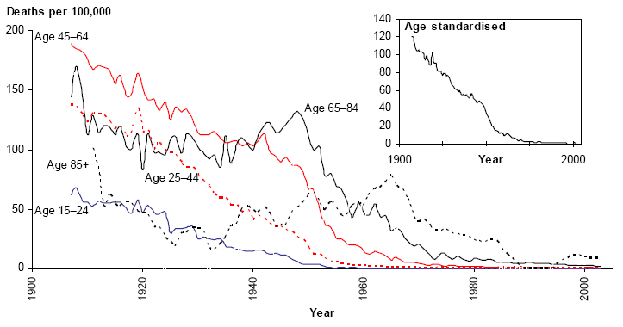
Source: AIHW, Mortality over the twentieth century in Australia, 2006, p. 52; data: AIHW GRIM Books.
Figure 1.5: Age-specific and age-standardised death rates for TB, females, 1907-2003
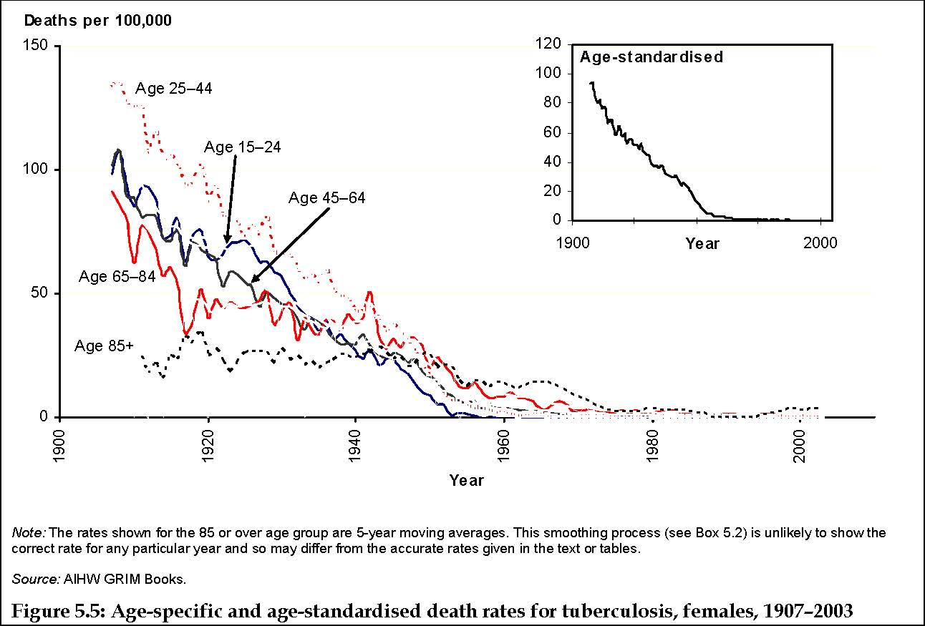
Source: AIHW, Mortality over the twentieth century in Australia, 2006, p. 52; data: AIHW GRIM Books.
Among those aged 45-64 years, TB claimed almost 180 deaths per 100,000 males and 89 deaths per 100,000 females. For males in the 64–84 year age group, the death rate in 1910 was 112 per 100,000 population and for females, the rate was 62 per 100,000. The death rate for males and females aged 25–44 was around 125 per 100,000 population (Figure 1.4 and Figure 1.5). By the 1980s, deaths from TB had been ‘virtually eliminated’ in Australia, and by 2000, there was less than one death per 100,000 population.25 At the end of the century, Australia had one of the lowest rates of TB infection in the world.
The substantial decline in the death rate from TB was attributed to improved socioeconomic circumstances; better living conditions, especially less overcrowding; TB sanatoria (establishments for the isolation, treatment and convalescence of people with TB); effective treatment with antibiotics; and the success of the post-World War II National TB Campaign that included immunisation and mass chest X-ray screening.25
TB was a disease that was stigmatising and much feared by the population. The discovery of streptomycin in 1944 meant that an effective treatment was available from about 1947 onwards, and allowed a program of population screening and treatment to begin. It included the establishment of mass chest X-ray screening using miniature radiography, effective containment and treatment of active cases in sanatoria, and the implementation of a universal BCG (bacillus Calmette-Guérin) tuberculosis vaccination strategy.
By the end of the century, states and territories were responsible for providing and managing TB services in Australia and for continuing the close working relationship between public health units, laboratories (including TB reference laboratories), clinicians and TB treatment services.71 The federal government monitored the incidence and prevalence of TB nationally using information from state and territory health authorities and laboratory services.71
Public health practices
The public health principles that were applied to the control of TB included a focus on the whole population, and a strategy that was multi-faceted with prevention, diagnosis and treatment elements. The universal approach worked to reduce differences in health between segments of society, although there were some areas that required further attention. The actions were effective, based on scientific evidence and skilled logistical support, and used a mix of approaches to address all areas of risk.
From 1991, the National Notifiable Diseases Surveillance System (NNDSS) collated national data on notified cases of TB reported to State and Territory public health authorities. The Australian Tuberculosis Reporting Scheme, run by the Australian Mycobacterium Reference Laboratory Network, reported cases of bacteriologically confirmed TB and drug resistance from 1994. Reports on TB notifications were published annually in Australia’s Communicable Diseases Intelligence.72 Australia implemented the WHO recommended five-point strategy (1993) known as Directly Observed Treatments - Short Course (DOTS) for TB control, with appropriate modifications for a low incidence, industrialised country.
In 1999, the Communicable Diseases Network Australia (CDNA), concerned about difficulties that had arisen in TB control in other industrialised nations, and a perceived decline in TB expertise within Australia, formed the National Tuberculosis Advisory Committee (NTAC) with representation from the Commonwealth, and all state and territory governments:
- to provide strategic, expert advice to CDNA on a coordinated, national and international approach to TB control; and
- to develop and review nationally agreed plans for the control of TB in Australia.71
The resulting National Tuberculosis Control Program required all levels of government to work together to ensure that Australia continued to enjoy one of the lowest rates of TB infection in the world. Key strategies of the Program included:
- active and passive case finding for early diagnosis of TB through clinical and laboratory services;
- prompt, effective free treatment of people with active TB in supervised programs; and
- timely surveillance and national reporting of TB incidence, drug resistance, and treatment outcomes to inform program evaluation.
BCG vaccination, which reduced invasive TB and death by about 70%, was indicated in high-risk groups, including newborn Aboriginal and Torres Strait Islander babies in areas where TB was prevalent, and neonates and children who were likely to travel to or live in countries where TB was common.73 The low rate of infection in Australia was maintained during periods of large-scale migration from countries with much higher TB prevalence rates, by using effective pre-migration screening and specialised, multi-disciplinary TB services in the states and territories.71 Globally, TB remained a major health problem, especially in the WHO regions of South East Asia, and the Western Pacific (in which Australia is located) which had a reported notification rate in 2003 of 57 cases per 100,000 population.74
Factors critical to success
The death rate from TB fell rapidly with the improvements in sanitation, living standards and housing from the start of the century, emphasising again the importance of these interventions to the public’s health. With the introduction of the National TB Campaign after World War II, the annual rate of TB declined from 48 cases per 100,000 population in the late 1940s to around five cases per 100,000 population per year by the end of the century.75 The campaign was cited as the ‘archetypal mass screening program’.76 The implementation was led by ex-military doctors who were ‘systematic, disciplined, and logistically skilled’76 and this played a large part in its success as it was rolled out across the country.
Other factors included community acquiescence with screening radiography and the removal to sanatoria of infected individuals.76 Compliance with treatment was facilitated by the payment of a pension while people were undergoing treatment, which generally resulted in removal from family for lengthy periods of time, and subsequent loss of employment.
The National TB Campaign and subsequent activities had a measurable impact on the health of the population (Figure 1.4 and Figure 1.6). The Campaign addressed a significant public health problem, as TB was one of the three leading causes of death at the beginning of the century. It was ambitious in scope, functioned nation-wide as a universal program for over thirty years, and employed cost-effective strategies, given its scale.
Surveillance and monitoring of TB cases continued to play an important preventive role in Australia at the start of the 21st century. From 2000 to 2006, the annual rate of TB remained relatively stable at around five cases per 100,000 population, despite Australia’s continued intake of migrants from areas of high TB prevalence.76
Future challenges
Screening, early intervention and treatment of TB almost eliminated the disease, except in refugee, homeless and Aboriginal populations, and in those migrating from overseas countries with high rates of TB (Figure 1.6). TB and HIV co-infection emerged as a major global public health issue. While co-infection was rare in Australia, HIV testing of TB patients was complete in only about one third of Australian cases.
Fortunately, multi-drug resistant TB (MDRTB) was uncommon in Australia, and remained at less than two per cent of new cases annually; however, the risk of MDRTB persisted, as most notified cases were of people from countries with high rates of drug resistant TB.76
In 2005, the rate of TB infection in the non-Indigenous Australian-born population was 0.8 cases per 100,000 population compared to 20.6 cases per 100,000 population in those born overseas. The rate of TB infection in Indigenous Australians was 5.9 cases per 100,000 population, seven times greater than that for non-Indigenous Australians.77
Figure 1.6: TB incidence rates by Indigenous status and country of birth, Australia, 1991-2005
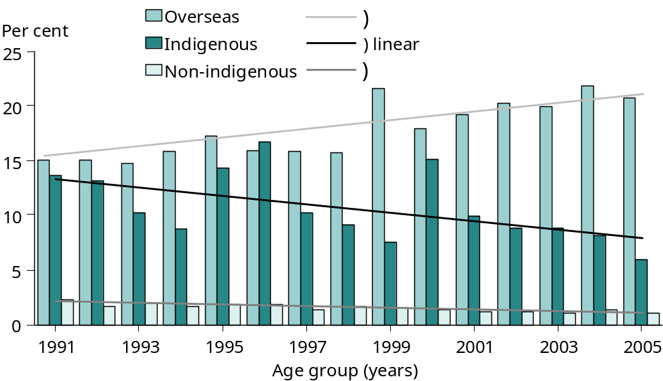
Source: Roche et al, Communicable Diseases Intelligence, vol. 31, 2007, p. 74.
The Indigenous population had higher rates of infection, active disease, hospitalisation and death from TB than the non-Indigenous Australian-born population, and the disparity changed little over the last decade of the century, despite TB control programs being in place (although NTAC noted that careful interpretation of data was needed as numbers were small, Indigenous status reporting was not complete, and geographic variability was significant).78 Contributing factors included socioeconomic disadvantage, the presence of co-morbidities (e.g., diabetes and renal disease), smoking, alcohol abuse, poor nutrition, overcrowding and poor living conditions, and social and geographical isolation.79
By the end of the century, the following remained challenges in applying more successful interventions in populations who were most at risk of TB:
- addressing ‘upstream’ contributors to the increased risk of TB in Indigenous Australians, such as socioeconomic disadvantage, poor nutrition and overcrowded living conditions;
- extending effective TB control programs and identifying measures likely to be more successful in controlling TB in Indigenous communities;
- supporting pre-migration TB screening and post-migration treatment programs for migrants to Australia;
- maintaining access to cost-free TB treatment programs and diligent contact tracing, enlisting the support of community peers, and providing essential health information in appropriate community languages for overseas-born Australians; and
- remaining alert to the global TB situation, and contributing to control efforts in the WHO regions of South East Asia and the Western Pacific.

HIV/AIDS Strategy
1985 onwards
‘HIV/AIDS is a bloodborne viral disease of the late twentieth century that has become a worldwide threat.’ — AIHW, Mortality over the twentieth century in Australia, 2006, p. 77. 25
Human Immunodeficiency Virus (HIV) is the virus that causes the Acquired Immune Deficiency Syndrome (AIDS). First identified in 1981, HIV resulted in a worldwide epidemic.80 HIV impairs a person’s immune capacity, making them susceptible to a range of other infections. In Australia, the majority of HIV cases were diagnosed in gay and other homosexually active men, with much smaller numbers in people using injecting drugs, infected by contaminated blood or needle stick injury, or exposed through heterosexual contact.25
The HIV/AIDS epidemic in Australia was controlled early by public health intervention and effective community action. Rates of infection significantly slowed after 1994, although they began rising again around the year 2000. By 2005, death rates from HIV/AIDS had fallen to one death per 100,000 population for males (from the peak of 6.4 deaths per 100,000 males in 1993) and 0.1 deaths per 100,000 population for females (from 0.3 deaths per 100,000 females in 1995). These falls are evident across the age groups shown in Figure 1.7.81
Figure 1.7: HIV/AIDS - age-specific death rates, males, 1988-2003
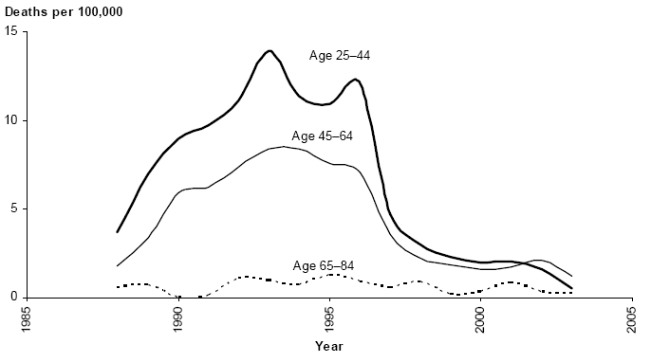
Source: AIHW, Mortality over the twentieth century in Australia, 2006, p. 77; data: AIHW GRIM Books.
The number of people diagnosed with AIDS in Australia declined from 817 in 1995 to 213 in 2001, and was stable at around 240 diagnoses per year over the five years to 2006 (Figure 1.8).82 This decline was attributed to reducing HIV incidence from 1986 onwards and to the wide availability of effective antiretroviral treatments from 1996.82
Figure 1.8: Number of diagnoses of HIV infection and AIDS, 1984-2006
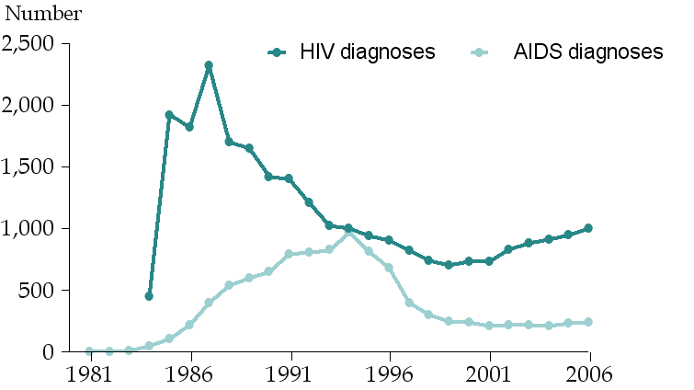
Source: National Centre in HIV Epidemiology and Clinical Research, HIV/AIDS, viral hepatitis and sexually transmissible infections in Australia: Annual Surveillance report, 2007, 2007, p. 9.
Surveillance data (which adjusted AIDS diagnoses for reporting delays and HIV diagnoses for multiple reporting) showed that the annual number of new HIV diagnoses increased after a 15-year decline, rising from 763 cases in 2000 to 998 in 2006.82 A growing number of these diagnoses were for HIV infections acquired in the previous year (‘newly acquired HIV’ means that evidence from blood tests suggests that the infection has been acquired in the year in question) (Figure 1.8).
Public health practices
The spread of HIV/AIDS was controlled by a relatively rapid public health intervention, and, although 6,723 people had died in Australia from AIDS by the end of 2006, the rate of infection slowed substantially from 1994. Safe sex and safer injecting campaigns, blood supply screening, infection-control guidelines and the introduction of new treatments contributed to the decline in HIV/AIDS mortality.3
Survey respondents: ‘The approach to HIV/AIDS was exemplary and Australia in my view did as well as any country in the world.’
‘In May 1985, Australia was the first country to introduce HIV screening in blood banks when
Dr Neal Blewett brought the testing kits to Australia from the USA in May 1985. This, combined with needle exchange programs and extensive sexual health education for young people and people in at risk groups, limited to some extent the epidemic that was so catastrophic in other countries where these measures were not implemented.’
In 1985, Australian governments committed to a harm minimisation approach to address the HIV epidemic.83 The first National HIV/AIDS Strategy84 in 1989 set out specific anti-HIV measures, which included:
- blood bank screening (Box 1.4);
- needle exchange programs; and
- sexual health education in schools and for ‘at risk’ communities.86
The commitment to a harm minimisation approach enabled difficult topics to be addressed early. The National HIV/AIDS Strategy: revitalising Australia's response 2005-2008 was the fifth version of the strategy.85
‘AIDS first appeared in the media as a deadly disease spread primarily among homosexual men who were perceived as having infected the blood supply. The shape and extent of the threat to “the general public” was unknown. Announcements of the first identification of an AIDS “case” in Australia, then of HIV transmission through the blood supply and the death of three Queensland infants with HIV from blood transfusions each raised media panic. The response on the part of gay communities in Australian cities from mid-1983 was to develop education and care programs, which effectively changed behaviour before governments became active. The response on the part of the federal government… was exceptionally proactive, putting Australia well in advance of other countries.’ —J Ballard, HIV and hepatitis, 2005, p. 9.85
The lack of a curative medical response to AIDS meant that there was ample scope for public health intervention, such as health education and promotion of behavioural change, to contain the spread of the disease. AIDS Councils established early by gay communities rapidly promoted safe sex awareness messages, and are thought to have been responsible for the early decline in HIV transmission, well before government-funded education programs were initiated.85 The partnership approach taken by the Australian government involved affected communities, all levels of government, service providers and researchers.86 This allowed for a high level of consultation and collaboration to prevent, manage and treat HIV/AIDS in the community.86
Factors critical to success
The prevention and control of HIV/AIDS in Australia was successful because, with strong national leadership, the need for preventive measures in sub-populations such as those using injecting drugs and sex workers, was acknowledged and tackled early. The approach adopted by the national government was described as ‘an internationally heralded feature of the Australian response’.85
The early preparation and ongoing revitalisation of the national strategy, as well as a policy commitment to using a harm minimisation approach, also contributed to success in this area. Forging a dedicated AIDS medical community across specialties to work collaboratively with NGOs involved with affected people, was another arm of Australia’s effective response.86 National monitoring systems which guaranteed confidentiality, and research into risk factors, patterns of transmission and treatment options also strengthened the public health system response.
Innovative social marketing (e.g., the ‘Grim Reaper’ HIV/AIDS media campaign launched in 1987) was used successfully to raise awareness in the population about safe sexual practices and other risk reduction measures. Inadvertent infection was addressed by the implementation of donor screening and blood testing to ensure the safety of the blood supply.

Grim Reaper (AIDS)
Source: Noel Butlin Archives Centre, Australian National University: National AIDS Archive Collection.
These factors had a significant impact in containing the transmission of HIV and improving the lives of those already infected. Later increases in the rate of HIV infection in Australia, however, confirmed that it was necessary to continue these and other strategies.
Cost-effectiveness
In 2003, Abelson and colleagues estimated that the cost of programs to reduce HIV/AIDS from 1984 to 2010 was $607 million.87 These included education and prevention programs from 1984, which targeted both high-risk and general population groups. A reduction of 25% in the HIV/AIDS transmission rate was accredited to the costed programs, which were fully attributable to public health effort. The net benefit was estimated at $2.541 billion.
Future challenges
The need for a continued effective response was underlined by the increase in the annual number of new HIV diagnoses and changes in the pattern of transmission. Although the majority of new HIV infections arose in men with a history of homosexual contact, the proportion attributed to heterosexual contact increased from 7% before 1996, to 24.5% in newly diagnosed HIV cases in 2006.82 These issues required a revitalising of prevention and education efforts focusing on key objectives, including prevention of the spread of sexually transmissible infections (STIs) and HIV/AIDS, and maximising the quality of life for those living with HIV/AIDS.86
Aboriginal and Torres Strait Islander people were regarded as a priority population group for prevention and health promotion activities under the national strategy.86 Rates of HIV diagnoses were approximately the same for the Aboriginal and Torres Strait Islander and the non-Indigenous populations in the five years 1996-2000, with both rates declining over this period (Figure 1.9). Previous analyses of case data (1992-1998) suggested that Indigenous Australians had not experienced the decrease in HIV that occurred in the non-Indigenous population.88 A study (1983-2002) in WA demonstrated that this population was at greater risk of HIV transmission than had been previously thought.89 Subsequent national data , however, revealed that, while the HIV rate had increased in 2002 to 7.5 per 100,000 population, it declined to 4.9 per 100,000 population in 2006 (while increasing in the non-Indigenous population to 5.1 per 100,000 population in 2006) (Figure 1.9).82
‘Groups such as people who inject drugs, young people, people in custodial settings and Aboriginal and Torres Strait Islander people may be at risk of HIV, STIs and hepatitis C. Interventions aimed at these groups must account for this multiple risk and offer prevention, testing, treatment and support services that recognise and address the possibility of co-infection with other conditions.’
—Foreword to the National HIV/AIDS Strategy: revitalising Australia's response 2005-2008 by the Hon. T Abbott, MP, The Minister for Health and Ageing.86
Figure 1.9: Newly diagnosed HIV infection by Indigenous status and year, 1997-2006
1997
1998
1999
2000
2001
2002
2003
2004
2005
2006
0
2
4
6
8
10
Aboriginal and Torres Strait Islander
Non-Indigenous
Age standardised rate per
100,000 population
Source: National Centre in HIV Epidemiology and Clinical Research, HIV/AIDS, viral hepatitis and sexually transmissible infections in Australia: annual surveillance report, 2007, 2007, p. 19.
It is important to note that Indigenous rates were calculated on small numbers of cases. The data did, however, indicate relatively high rates of infection from heterosexual contact and injecting drug use, which differed from the pattern of transmission in the non-Indigenous population, suggesting that different prevention strategies were needed.82 The complementary National Aboriginal and Torres Strait Islander sexual health and bloodborne virus strategy outlined a national approach to preventing the spread of hepatitis C, HIV/AIDS and other sexually transmissible infections in Aboriginal and Torres Strait Islander communities.86

Box 1.4 Safety of the blood supply, 1985-
Recognition that bloodborne viruses such as HIV had the capacity to infect recipients of blood products (e.g., people with haemophilia) and that the government was responsible for the blood supply, led to measures to improve the safety of the blood supply. Before testing for HIV became possible, there were over 500 cases (up to 1998) of HIV transmission as a result of transfusion of infected blood or blood products90 and almost everyone who received HIV-contaminated products became infected.91
Diagnostic tests for HIV were developed soon after the virus was isolated in the USA in April 1984. In Australia, the ability to test for HIV was used to alert the public to the risk of blood contamination and became a focus for early government action.92 Screening of blood donations for HIV was implemented in 1985.93
Standard precautions for the care and treatment of patients, including the handling of blood to prevent the transmission of infection were drawn up by the NHMRC in 1996 and implemented in health care settings.94 Blood, blood components and plasma derivatives were regulated under the Therapeutic Goods Act 1989.95

Organised mass immunisation
1932 onwards
Vaccines against smallpox and typhoid were available in Australia from the early 1800s.96 The first vaccine material arrived in Sydney in 1804 and was used to start a local, voluntary smallpox vaccination program. Vaccination was identified as ‘the first modern public health activity undertaken by the state’⁵, and Australia earned a respected record in the development of vaccines and vaccination programs over the 20th century.
Professor Sir Gustav Nossal, outlining the history of vaccine development from World War I onwards in Australia, described the important advances in vaccine technology and delivery made by many scientists working at notable Australian institutions (e.g., Commonwealth Serum Laboratories [CSL] and the Walter and Eliza Hall Institute).97 The CSL were in charge of vaccine production for the nation from the middle of the 20th century. These included the Salk vaccine (inactivated polio vaccine) and a live-attenuated, intranasal influenza vaccine given to 20,000 army recruits during World War II. Advances in the development of human vaccines by Australian scientists (including Sir Frank Macfarlane Burnett) produced vaccines for cholera, tuberculosis, Q fever, and the human papilloma virus. Other Australian researchers undertook pioneering work on Helicobacter pylori and malaria.
By the end of the century, public health and clinical research into vaccine-preventable diseases and vaccines was undertaken in a number of centres throughout Australia. These included the Collaborative Research Centre for Vaccine Technology (established in 1993), and the National Centre for Immunisation Research and Surveillance of Vaccine-preventable Diseases (established in 1997), which strengthened and integrated surveillance, research and evaluation of these diseases and measures to prevent them.98
The process that delivered vaccination in an organised and cost-effective way to the populations in need was equally important, and essential to achieve the required level of ‘herd immunity’ against the infectious diseases. As a result of immunisation strategies conducted through the century, Australia was declared polio-free in 2000, with measles, rubella and Haemophilus influenzae type b infection (Hib) close to being eliminated.99,100
The following Sub-sections focus on organised immunisation for whole populations – for both children (1.3.1) and adults (1.3.2).

Organised childhood immunisation
1932 onwards
‘Immunisation is a simple, safe and effective way of protecting children against certain diseases. The risks of these diseases are far greater than the very small risks of immunisation.’ —Immunise Australia Program. 101
In 1932, diphtheria vaccination was introduced nationally for children. With the subsequent use of vaccines against tetanus (1939), whooping cough (pertussis) (1942), and poliomyelitis (1955), and against measles, mumps and rubella from the 1960s, deaths from vaccine-preventable diseases decreased by more than 99%, despite significant growth in the population.98
This dramatic decline was the result of specific vaccination programs (Figure 1.10). In 2001, it was estimated that at least 78,000 Australian lives had been saved, and substantial illness prevented, through vaccinations for diphtheria, whooping cough, tetanus, measles and poliomyelitis (Box 1.1).98 Prevention was vital because many of these diseases, especially those caused by viruses (e.g., poliomyelitis, measles, and hepatitis A), had no specific treatments or had drug-resistant strains.98
Figure 1.10: Deaths from selected vaccine-preventable diseases, 1907-2000 (measles, pertussis, diphtheria, tetanus and polio)
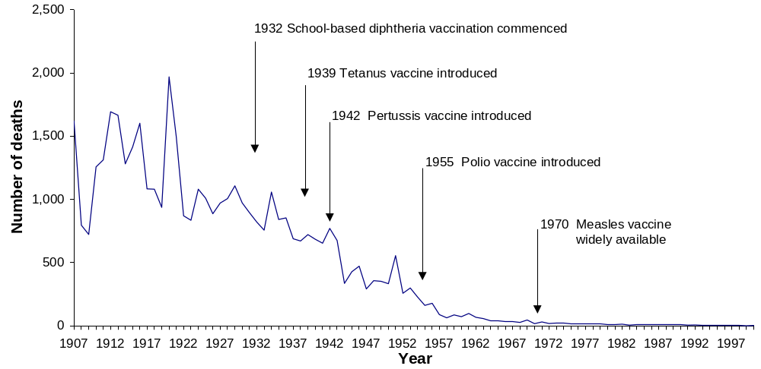
Source: Burgess, NSW Public Health Bulletin, vol. 14, 2003, p. 3; citing AIHW, Australian long-term trends in mortality, AIHW, Canberra, 2002.
Vaccination against other infections (such as Haemophilus influenzae type b infection [Hib], hepatitis B, invasive pneumococcal disease and meningococcal disease type c) effectively extended protection. For example, after 1993, with the introduction of the Hib vaccine, the incidence of the disease fell immediately (Figure 1.11), and, by the year 2000, more than an estimated 100 deaths in children under the age of five had been prevented.1⁰² Vaccination was also targeted specifically at high-risk population groups (e.g., hepatitis A and pneumococcal immunisation for Indigenous children).103
Figure 1.11: Haemophilus influenzae type b disease notification rate, 1991-2002
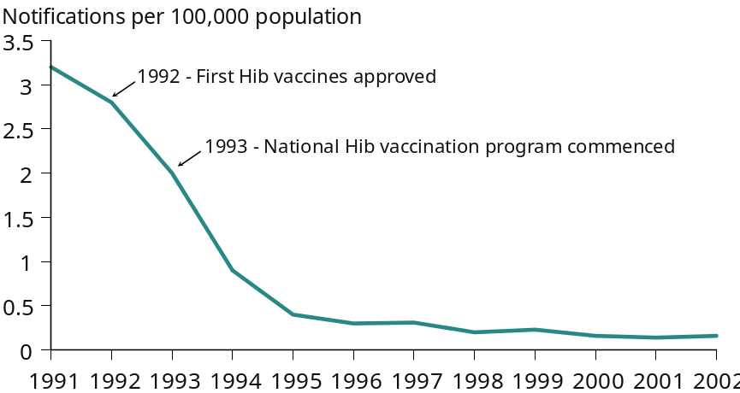
Source: Brotherton et al., Communicable Diseases Intelligence, vol. 8, 2004, p. S95.
The case of measles indicated a continuing need for vigilance, proactive public health surveillance, and the implementation of refinements in immunisation techniques and programs. Although a vaccine for measles was included in childhood vaccination schedules in 1971, the immunised population (coverage) remained too low to confer herd immunity. It stayed low even after the first national measles campaign in 1988 (with major measles outbreaks in 1993-1994), and after changes in the immunisation schedule, which introduced a second dose of MMR (measles, mumps, rubella vaccine) in 1994.10⁴
The national Measles Control Campaign, conducted by the Australian government in conjunction with all state and territory governments in 1998, included the administration of a mass ‘catch up’ dose of the vaccination to all primary school-aged children, and lowered the recommended age for the second dose of MMR in 1999.10⁴ It was estimated that 96% of children aged five to 12 years (1.7 million children) had received the recommended two doses of MMR vaccine after the 1998 Measles Control Campaign10⁵; and significant increases in the level of protection against measles among preschool and primary school age children, to 89% and 94% (from 84% before the campaign) respectively, were demonstrated in analyses of post-campaign sera.106
The ultimate aim was to interrupt native measles’ transmission, as had been achieved in other countries (e.g., the UK, the USA and Finland).10⁴ Although coverage in children in Australia was high, a group of young adults who missed out on earlier measures to extend coverage remained susceptible to the disease, and a young adult MMR vaccination campaign was conducted during 2001 to reach this group.10² Later outbreaks of measles involved people who were infected with the disease overseas. To sustain control of measles over time, greater effort in young adults and continuing high coverage in children were required.10² In addition, young adults planning overseas travel to areas where measles was currently endemic were encouraged to confirm their measles immunity or have a second dose of MMR. High uniform vaccination coverage against measles was needed to prevent its reintroduction until global eradication could be achieved, and it was expected that WHO would set a target date for full measles’ elimination in the Western Pacific Region, including Australia.10^{2,}107
There was a reduction of 99% in measles’ notifications from 1994 (when 4,792 cases were notified) to 2004 (when only 45 cases were notified).13 In the first decade of the 20th century for which there were reliable deaths’ data (1907-1916), there were 2,143 deaths from measles, but only a single death during the period 1997 to 2004.13
Public health practices
By the end of the 20th century, the public health approach was one of a government-funded, universal childhood immunisation program to protect against 12 vaccine-preventable diseases, supported by immunisation registers and vaccine research.108 The national immunisation schedule included diphtheria, mumps, pertussis, rubella, tetanus, Hib, hepatitis B, meningococcal type c infection, and chicken pox.109 Data from the Australian Childhood Immunisation Register (ACIR), which operated by Medicare Australia from 1996, showed the increasing proportion of children fully vaccinated at key ages (Figure 1.12).110
Immunisation was supported by nation-wide monitoring of incidence and outbreaks of vaccine-preventable diseases, and active countermeasures (e.g., community education campaigns) to increase immunisation coverage when it fell below acceptable rates. Notifications and contact tracing of cases of vaccine-preventable diseases and other control measures were carried out by public health units in all States and Territories.
Figure 1.12: Childhood immunisation standard coverage by age groups, December 1998 to March 2007
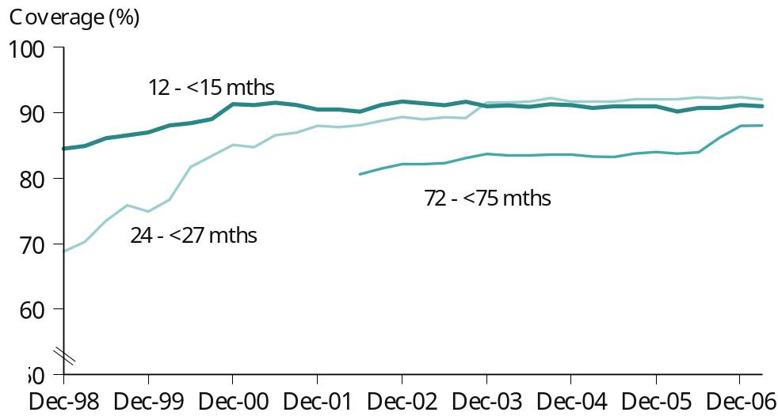
Source: Medicare Australia, Australian Childhood Immunisation Register statistics: immunisation coverage graphs - March 2007, 2007.
Factors critical to success
For many years, Australian immunisation measures did not reach the required level to prevent outbreaks of whooping cough and measles. It was only after the creation of a national register (the ACIR) that country-wide coverage rates could be monitored and the childhood immunisation program considered a success. The leadership of the National Immunisation Program (NIP) (a joint initiative of Australian, State and Territory governments), public funding of vaccines and efficient vaccination delivery systems (e.g., via general practitioners, local government, Aboriginal Medical Services) were critical factors in ensuring the high coverage rates that conferred herd immunity and limited the number of cases of infectious disease.111
The ACIR enabled parents to track their child’s vaccination status, and coverage rates to be monitored. The Immunise Australia program, launched in 1997, included educational activities for parents and providers to raise community knowledge and awareness, and to create a more supportive climate for childhood immunisation.
Vaccine funding was approved by the Federal Minister for Health and Ageing under the National Health Act 1953.100 State and Territory legislation enabled the collection and reporting of communicable disease information. National legislation provided for some parental payments to be tied to the immunisation status of their children112, with model provisions for the certification of children’s immunisation status on school and child care entry developed by the National Public Health Partnership.113
The childhood vaccination program had a measurable impact on children’s health, as well as the general population. It addressed a significant health problem, was ambitious in scope, functioned nationally as a universal program for over five years, used integrated vaccines (judged to be cost-effective) at the scale required to provide adequate coverage, and was cost-effective. To remain successful, herd immunity across the adult population needed to be maintained.
Cost-effectiveness
Box 1.5 Poliomyelitis eradication: the Polio plus campaign, 1980-2000
Poliomyelitis (‘polio’) or infantile paralysis is a viral paralytic disease caused by the poliovirus. From the 1940s through the 1950s and into the early 1960s, Australia had epidemics of polio every second or third summer, according to Professor Sir Gustav Nossal. He has been an immunologist for over 40 years, and spent 25 years with the WHO, most recently as the Chairman of its Global Program for Vaccination. He remembers those times when ‘my mother wouldn't allow us to go to the movies of a Saturday afternoon because that would be a crowded place in which we’d be sure to catch polio’.114 Wards in hospitals were filled with people on respirators (the so-called ‘iron lungs’) because their breathing muscles had become paralysed.115
Australia played a part in the global eradication of polio, and, in 2000, Australia, and its region of the Pacific, were declared polio-free.
The Polio plus campaign, a partnership between WHO and Rotary International, developed into one of the largest public health initiatives.115 When Polio plus began, polio was circulating in 125 countries, and the reported incidence (of 350,000 cases per year) was almost certainly an underestimate. The eradication campaign used four linked strategies: high routine infant immunisation rates; National Immunisation Days to mobilise community effort, when all children under five years were immunised on a given day (regardless of their previous immunisation status) with the aid of ‘an army of volunteers’; good surveillance of all cases of paralysis; and lastly, as eradication campaigns approach completion, ‘mop-up’ campaigns to track down the last cases of wild polio in the communities, ‘breaking the last few chains of transmission.’115
Vaccine expenditure under the NIP in 2004-05 was estimated at $285 million (a large increase on the $13 million in 1996). Some of the benefits and costs of universal childhood immunisation follow.⁸⁷
- Measles - cost of immunisation programs during 1970 to 2003 estimated at $52 million;
- saved an estimated 95 lives over the same period and averted around four million cases. Measles’ notifications fell from around 100,000 to under 2,000 cases a year;
- savings to government included $8.5 billion, mainly in health care expenditure;
- net benefit estimated at over $9.1 billion.
- Hib - cost of immunisation programs during 1991-2003 estimated at $165 million;
- saved an estimated 78 lives over the same period and averted around 3,600 cases from 1993 to 2003. An estimated 350 cases were averted annually during the 1990s;
- net benefit estimated at $10 million.
Future challenges
In March 2006, 90% of one year old and 92% of two year old children were fully immunised.116 Participation in vaccination programs had to be maintained at high rates to ensure herd immunity, and to eliminate further vaccine-preventable diseases.98 Furthermore, despite low or absent disease incidence in Australia, the Western Pacific region and the rest of the world were not disease-free, and the threat of disease rose when immunisation coverage dropped. It was important to maintain immunity in adults, via adult maintenance immunisation, for the ‘childhood diseases’ of whooping cough, diphtheria and tetanus.
Additional measures were required to ensure better recruitment of ‘hard to reach’ children from those population groups who were often under-immunised (e.g., those from socioeconomically disadvantaged families, recently arrived migrants, those who were non-English speaking). Greater efforts were also needed to increase immunisation rates for very young Aboriginal and Torres Strait Islander children, especially for the pneumococcal vaccine. A 2004 study estimated that, although the uptake of the pneumococcal conjugate vaccine for this group had increased in most jurisdictions from 2001, coverage was less than 50% in all jurisdictions except the NT, WA and Queensland.117

Organised adult immunisation
1999 onwards
‘… administration of … influenza vaccine to individuals at risk of complications of infection is the single most important measure in preventing … influenza infection and … mortality.’ —National Health and Medical Research Council, 2003.118
Influenza or ‘flu’ is a highly contagious viral infection that is transmitted by sneezing and coughing, and causes illness lasting for more than a week. In adults, symptoms are fatigue, fever, chills, loss of appetite, headache and muscle pain and for some, cough and nasal discharge. Influenza can be fatal and deaths attributed to the disease are thought to be substantially under-reported; it was estimated that the true death rate from influenza was up to eight times higher than that reported.119 Vaccination against influenza effectively reduces the risk of being infected with the disease (by up to 70% in people aged over 65 years).118 People aged 65 years and older (50 years and over for Aboriginal and Torres Strait Islander peoples) are at higher risk of serious illness, complications and death from influenza (although these may also occur in younger people).120
A common complication of both influenza and pneumococcal disease is pneumonia, an inflammation of the lung tissues. Pneumococcal pneumonia is the commonest form of serious pneumococcal disease in adults.121 Other complications are septicaemia (blood infection) and meningitis (inflammation of the tissue covering the brain). Both pneumococcal disease and influenza have similar impacts, especially on older people, and vaccination programs are aimed at reducing the impact of both diseases.121
Influenza death rates showed a steady decline from 1997-1998 (Table 1.2). Although hospitalisation rates for influenza increased (after the lowest recorded rate of 9.4 hospitalisations per 100,000 population for 2001-2002), they were still well below those of 1997-1998 when adult vaccination programs were in their infancy.
Table 1.3: Trends in hospital separation and death rates for influenza and pneumonia, 1997-2004
Year | Hospital separation rates |  |  | Year |  | Death rates
 | Influenza | Pneumonia |  |  | Influenza |  | Pneumonia
 |  |  |  | 1997 | 1.3 |  | 12.4
1997-1998 | 21.2 | 354.3 |  | 1998 | 0.7 |  | 11.2
1998-1999 | 15.5 | 338.9 |  | 1999 | 0.4 |  | 10.3
1999-2000 | 13.6 | 319.9 |  | 2000 | 0.4 |  | 15.4
2000-2001 | 12.4 | 305.9 |  | 2001 | 0.2 |  | 13.8
2001-2002 | 9.4 | 311.7 |  | 2002 | 0.3 |  | 15.0
2002-2003 | 11.3 | 321.9 |  | 2003 | 0.3 |  | 16.8
2003-2004 | 13.8 | 324.8 |  | 2004 | 0.2 |  | 15.6
Source: AIHW, Australia’s health 2006, 2006, p. 110.
After large declines earlier in the century, followed by a decade of relative stability, later pneumonia death rates appeared to increase (although this might have partly reflected changes to automated cause of death coding).13 As with influenza, later hospitalisation rates for pneumonia remained below those of 1997-1998.
Public health practices
Unlike immunisation against other diseases, influenza vaccination is required annually to account for changes in the influenza virus itself. Therefore, the prevalence of different influenza strains was monitored, and annual vaccines tailored to provide the best protection against the specific influenza viruses likely to threaten our geographical region.119 The cost of providing sufficient vaccines for the immunisation target group (about 2.1 million people were vaccinated against influenza in 2004) was met by the Australian government through payments to the states and territories, while jurisdictional health departments met other costs and organised vaccine distribution to immunisation providers (e.g., general practitioners).121 Vaccine recipients made their usual arrangements (e.g., bulk-billing or co-payment) when they visited their doctor or other provider to receive their vaccination. Laboratory-confirmed influenza became a nationally notifiable disease in 2001 and all jurisdictions implemented and/or contributed to influenza notification.122
In 2004, the Australian government initiated a tender process to streamline influenza vaccine purchasing arrangements (previously, each jurisdiction had negotiated separately with the vaccine suppliers).123 The national tender process resulted in agreements with two companies to provide vaccine for three influenza seasons, thus enabling substantial savings and access to vaccine supply in the event of an influenza pandemic.124
Under the National Influenza Vaccine Program for Older Australians, influenza vaccination was funded by the Australian government for:
- all Australians aged 65 years and older;
- Aboriginal and Torres Strait Islanders aged 50 years and older;
- Aboriginal and Torres Strait Islanders aged 15-49 years where indicated (i.e., for those who were considered to be at high risk of complications and death from the disease); and
- younger people with underlying chronic illnesses (such as heart disease, respiratory disease and diabetes), which were likely to increase their vulnerability to influenza infection and its complications.120,118
The National Pneumococcal Vaccination Program for Older Australians, which commenced in 2005, provided free pneumococcal vaccine for:
- all Australians aged 65 years and older;
- Aboriginal and Torres Strait Islanders aged 50 years and older; and
- Aboriginal and Torres Strait Islanders aged 15-49 years considered to be at high risk of complications and death from pneumococcal disease.
These vaccination programs were also administered by general practitioners. The Adult Vaccination Survey, the fifth in a national series, was extended to assess pneumococcal, as well as influenza, vaccinations for the first time in 2004.123
A national surveillance system monitored seasonal influenza epidemics. Components included medical consultations for influenza-like illnesses from sentinel general practices across Australia, and laboratory-confirmed cases of influenza notified by the states and territories.122 The design of annual influenza vaccines (based on monitored changes in the virus) and the determination of the need for any additional public health measures (depending on the epidemic and/or pandemic nature of seasonal influenza) were based on this surveillance information.125
The federal budget (2006-07) included funding of $1.2 million to examine ways in which to redevelop the ACIR as a whole-of-life register. This was to extend the Register to include adult immunisations, such as those for tetanus, influenza and pneumococcal disease, and self-funded (as well as government-funded) vaccines, and new vaccines, thereby potentially improving health and reducing wastage of expensive vaccines.122
Factors critical to success
The National Influenza Vaccine Program for Older Australians started in 1999, and an estimated 2.1 million vaccinations were undertaken in 2004. Its effectiveness was assessed by surveying the target populations, with program coverage increasing from 69% in 1999 to 79% in 2004.121 International collaboration was another factor critical to success. Australian public health reference laboratories provided data to the WHO on local influenza strains as part of its global influenza monitoring program, in order to determine the appropriate influenza strains for the Australian vaccine each year. The national vaccination program against influenza for people most at risk was assessed as effective by the National Institute of Clinical Studies, which recommended coverage be extended.126
Similarly, the National Pneumococcal Vaccination Program for Older Australians was targeted to those who were most at risk. In 2004, before the program commenced, the vaccinated proportion of the target population was estimated to be only 51%. This was 1.3 million people out of about 2.6 million in the target group, and indicated the scale of the program that was required.121
Cost-effectiveness
In 1996, it was estimated that influenza was responsible for one million medical consultations, between 20,000 and 40,000 hospitalisations, 1,500 deaths and 1.5 million days off work each year, at a total economic cost of about $600 million annually in Australia.127 Influenza and pneumococcal vaccines were assessed as cost-effective for people aged 65 years and older.128 The effectiveness of the influenza vaccine in any given year varied, depending on the age and immune response of those who were vaccinated and the closeness of the ‘match’ between the virus strains in the vaccine and those prevailing in the community. Reviews showed that well-matched influenza vaccine was effective in preventing significant proportions of hospital admissions for influenza and pneumonia and deaths from all causes.129
Future challenges
Although the 2004 Adult Vaccination Survey indicated that 79% of people aged 65 years and over were vaccinated against influenza, only 42% of those younger than 65 years with high-risk conditions were vaccinated (Figure 1.13), and this group contributed significantly to hospitalisations for influenza.121
Figure 1.13: Influenza vaccination rates by age groups, 2004
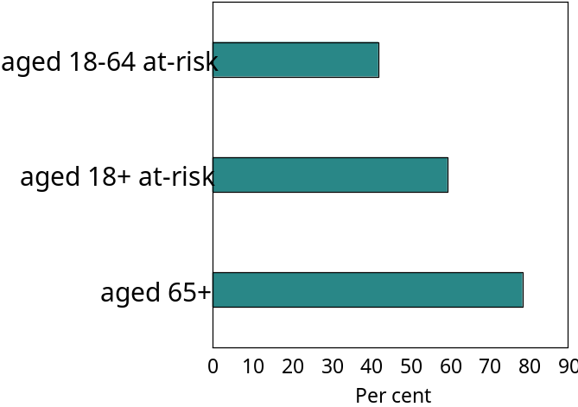
Source: National Institute of Clinical Studies, Evidence–practice gaps report, vol. 2, 2005, p. 27.
The National Institute of Clinical Studies identified the need to increase influenza vaccine coverage in people aged less than 65 years who were at risk due to pre-existing chronic health conditions, and this was also supported by the Influenza Specialist Group.120
The expansion of universal vaccination to younger groups of Indigenous people was also suggested as a measure that would significantly improve the health of this vulnerable population group.130

Aseptic procedures and antimicrobial medicines
1901 onwards
The recognition by Ignaz Semmelweis in 1847 that the incidence of postnatal infection of women could be drastically cut through the use of hand-washing in obstetric clinics, was an important precursor to the later development of germ theory and surgical instrument sterilisation.131 In 1870, British surgeon Joseph Lister introduced aseptic surgical techniques, which reduced infection and opened the door to modern medical and surgical practices. Strict adherence to aseptic techniques and hand-washing remained the cornerstone of infection prevention.
The development of antibiotics and other antimicrobial medicines played a further role in the decline of infectious diseases. Penicillin was developed for medical use in the early 1940s by the Australian researcher Howard Florey and his team, and was first produced in substantial quantities to treat sick and wounded soldiers. 132 It became a widely available medical product for the treatment of previously incurable bacterial illnesses, with fewer side effects than the sulphonamide (sulpha) drugs, which had been in use from the 1930s.
The development of antimicrobial medicines, including antibiotics, saved the lives of many people with streptococcal or staphylococcal infections, gonorrhoea, syphilis, tuberculosis or other infections. Drugs were also developed to treat certain viral diseases (e.g., herpes, HIV and HCV infections), fungal diseases (e.g., candidiasis and histoplasmosis), and parasitic diseases (e.g., malaria). However, the rise of drug-resistant strains of some infectious agents causing these diseases was concerning and underscored the importance of disease prevention.
Antibiotics were used not only to treat and prevent infectious diseases in humans, but also to promote growth and to improve feed efficiency in intensively reared animals (e.g., poultry, pigs and feedlot cattle) and fish for human consumption. Such uses contributed to the development of antibiotic resistance, which became an international issue as resistance spread.
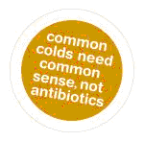
Source: National Prescribing Service Limited (NPS), ‘What you need to know about common colds’ [website], NPS, Sydney, 2006.
‘The increasing prevalence of antibiotic-resistant bacteria is a public health issue of major concern. Essential, life-saving antibiotics are becoming less effective and there are fewer alternatives available for treatment.’ —JETACAR, 1999.133
In 1998, the Australian Government Ministers for Health and Aged Care, and Agriculture, Fisheries and Forestry established a Joint Expert Technical Advisory Committee on Antibiotic Resistance (JETACAR) to examine this issue. JETACAR produced a report in 1999 which made recommendations on the future management of antibiotic use in food-producing animals. 133 A joint response by the two departments supported the recommendation for a national antibiotic resistance management program of regulatory controls, monitoring and surveillance, infection prevention, education and research.134
A Commonwealth Interdepartmental JETACAR Implementation Group was established to manage the Australian Government’s response to the problem, and the first National Summit on Antibiotic Resistance was held in 2001. This achieved broad commitment to develop a national antibiotic resistance management program.135 In 2001, the NHMRC established the Expert Advisory Group on Antimicrobial Resistance, whose role was to advise regulatory agencies, monitor antibiotic use and antibiotic resistance, and investigate the impact of antibiotic use on human health.136
The national Strategy for Antimicrobial Resistance (AMR) surveillance in Australia outlined a framework to address the recommendations made by JETACAR.137 The Australian Council for Safety and Quality in Health Care developed a National strategy to address health care-associated infections (2000-2005),138 which was continued by its successor, the Australian Commission for Safety and Quality in Health Care from 2006. While infection control measures in hospitals contributed significantly to reducing maternal and other deaths, drug resistance in many organisms remained a serious challenge (e.g., septic infection rates were increasing for older people in hospital).13
Future challenges
A surgeon reported: ‘Within our own institution [The Queen Elizabeth Hospital] we experienced an unrelenting increase in wound infections in orthopaedic, vascular and transplantation surgery. Expensive options involving new air conditioning systems, more infection control nurses and even ceasing some types of surgery were seriously mooted. Instead, it was decided to pursue an education project regarding the merits of hand washing, which was suggested and policed by nurses and consultant surgeons. Within months, incidence of new infections dropped dramatically to below benchmark levels where it has remained for more than 18 months.’
—GJ Maddern, ANZ Journal of Surgery, vol. 76, 2004, p. 720.
There was a need to reduce the rate of health care-associated infections (which were difficult and expensive to treat) through the linking of surveillance and intervention strategies. For instance, the activities of the South Australian Infection Control Service (established in 2001 as a voluntary network of infection control practitioners) had halved the rates of Methicillin-resistant Staphylococcus aureus (MRSA) infections in hospitals over two years, with a consequent reduction in hospital treatment costs.139 This improvement was attributed to regular feedback of data, and new hand washing techniques. Older, well-proven methods to contain infectious diseases, such as isolation and strict quarantine, also reduced MRSA spread in hospitals.
The rise of antibiotic-resistant bacteria was an increasing challenge for health care providers. Antibiotic-resistant bacteria first appeared in the 1950s, as a likely result of the widespread, indiscriminate use of antibiotics in human and animal populations. MRSA was only one of more than thirty species of resistant bacteria found in hospitals across Australia; and community-acquired cases began appearing, some with life-threatening consequences.
By the end of the 20th century, bloodstream infection due to Staphylococcus aureus was still not a nationally notifiable disease. Thus, data were not routinely collated at state and national levels, foregoing an estimation of disease burden and the monitoring of trends across Australia. Notifiability would also have provided a basis for investigating apparent sustained increases in incidence, and for evaluating the effectiveness of preventive and therapeutic interventions.140
Box 1.6 Control of hydatid disease in Tasmania, 1960s-
Zoonoses - infectious diseases occurring naturally in animals that can be potentially transmitted to humans - include various strains of influenza (e.g., ‘bird flu’), brucellosis, echinococcosis, listeriosis, Q fever and salmonellosis, among others. Echinococcosis or hydatid disease is a potentially fatal parasitic disease, common to humans and some animals, caused by infection with tapeworm larvae of the genus Echinococcus granulosus. In Australia, it was transmitted by wildlife in a prey-predator life cycle, with dogs and foxes as definitive hosts and herbivorous animals (e.g., sheep, kangaroos) as intermediate hosts. Although human hydatid disease occurred in almost all rural communities and grazing lands of the world, it carried ‘the added stigma that it was preventable’.141,142
The highest prevalence of human hydatid disease in the English-speaking world was recorded in Tasmania in the 1960s.143 The disease was also found in other areas of Australia, with a mean annual prevalence of 2.6 infections (ranging from 0.3 to 25.5) per 100,000 rural population; and a number of cases from urban areas found in NSW/ACT hospital studies (the latest of which studied cases from 1987-1992).144 At the launch of ‘The Travelling Parasite’, a public health educational video on the prevention of hydatid infection in 1996, it was described as occurring mostly in eastern NSW along the Great Dividing Range, with one person a day on average treated for it in Australia (although accurate data were not available).145 Despite being a notifiable disease, human hydatidosis was widely under-reported. Later information indicated that the disease was common in sheep-farming areas in NSW, ACT, Victoria, southwest WA and eastern Qld, and probably in SA. It was also found in cattle in the Kimberley region of WA, in northern Qld and near Darwin in the NT.146
A major contributing factor to the higher incidence in Tasmania - where the disease was common in sheep (with 60% carrying cysts) and rural dogs (12% carried the tapeworm) - was the habit of feeding sheep offal to working dogs.147,148 A large number of human infections resulted, some of which were fatal. A 1960 survey reported 92.5 human infections per 100,000 population.
Tasmania began a control program in 1962 to stop transmission of hydatid disease to humans. Public meetings were held and committees formed to raise awareness of the considerable health risk of hydatids. The Tasmanian program was aimed at stopping the hydatid life cycle by denying dogs access to offal from sheep, cattle, goats and pigs. It included regular testing of dogs for tapeworm infection, together with an educational program emphasising prevention. Abattoir monitoring of sheep enabled rural properties with infected dogs to be traced. With community support, the voluntary program became compulsory in 1966. The number of new human infections per year fell from 18 in 1966 to four in 1983, with equally striking falls in the prevalence of tapeworm in dogs and hydatid cysts in sheep (to less than 1%).
In 1996, Tasmania was declared ‘provisionally free’ of hydatid disease, as there had been no new infections in humans, dogs or commercial livestock for several years.149 Around 400,000 sheep and 60,000 cattle were inspected for hydatid cysts in abattoirs each year in Tasmania and, if found, further action (e.g., quarantine, slaughter of flock) was taken at the property of origin. It continued to be illegal to allow dogs access to livestock offal in Tasmania, and dogs entering the island had to have been previously treated for tapeworm.
Control of human hydatid disease in Tasmania was recognised worldwide as a most successful public health campaign and a model for hydatid control programs. It achieved success as a public health measure because of its emphasis on public participation, community education, and united action by many agencies including agriculture and health departments, underpinned by sound epidemiological principles.150 Hydatid disease ceased to be a notifiable disease in the year 2000.151

This page intentionally left blank

